Power Ups

* [Level Up!: The Guide to Great Video Game Design – page 356-360](https://books.google.co.uk/books?id=8w_ETFmHrewC&pg=PA356&lpg=PA356&dq=offensive+defensive+powerups&source=bl&ots=0tRZnf3fPg&sig=EaDzWbTH7Id9g5CmyrBDoYrbUIw&hl=en&sa=X&ved=0ahUKEwjx-NqEz6LZAhWCJ8AKHf4CBgUQ6AEIWzAG#v=onepage&q=offensive%20defensive%20poweru)
* [Rescues, Buffs & Skips: How to Design Mobile Game Power-Ups for Optimal IAP](http://www.scientificrevenue.com/blog/rescues-buffs-skips-how-to-design-mobile-game-power-ups-for-optimal-iap/)
* Defensive power ups; help boost player’s ability to survive damage and continue progressing
  + Health, extra life, invulnerability/invincibility etc
* Offensive power ups; improve or modify attacks
  + Ammo boosts, buffs, weapon upgrades etc

Tower of Babel

* Power ups are earned by perfectly stacking blocks
  + Wind, a bomb, transform a block into a totem, swap their block with yours
* All power ups affect opponent, players often thought that this was more fun due to increased competition

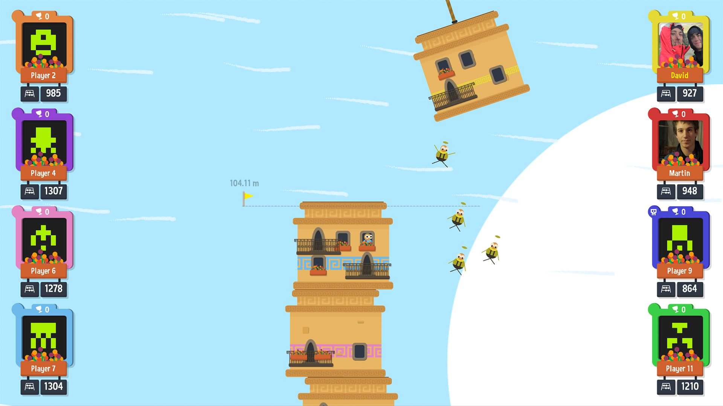

Figure 1: Wind power up in action during a player's turn in Tower of Babel

Fruit Ninja – simultaneous gameplay

* Players earn points towards obtaining bombs to throw at one another

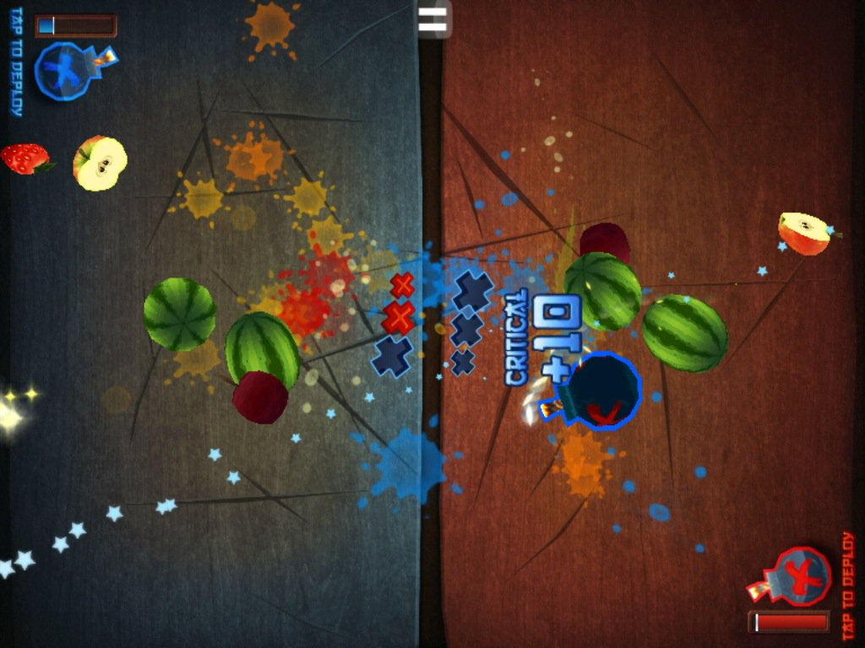

Figure 2: Blue player deploying a bomb during a multiplayer 'Classic Attack' game

Group Project Game

* All power ups are offensive
* Methods of obtaining
  + Players earn points towards a power-up
    - May create positive feedback loop since all power ups are offensive, players with higher points will be more likely to obtain a power up that will affect their opponent and thus are more likely to keep obtaining more and more points
  + **Power ups are obtained in the same way as fish**
    - Give players more choice 🡪 do they want a fish for points or a power up to try and affect their opponent
    - Maybe give losing player a higher chance of obtaining a power up
      * Does this go against symmetric gameplay aspect of brief?
* Players can hold more than one of each type of power up at any given time and can tap on an icon to deploy the corresponding power up during their opponents turn similar to Tower of Babel

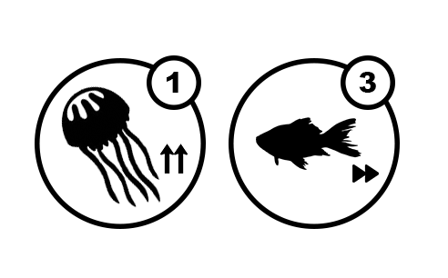

* Jellyfish frenzy power up – increases the amount of jellyfish that are likely to appear during an opponent’s turn
* Speed increase – increases the speed at which your opponent’s fish pool scrolls past with intention of making it more difficult for them to catch fish

Also considered bigger fish = lower points for one turn but this may not work due to the way in which the pools of fish are generated

UI

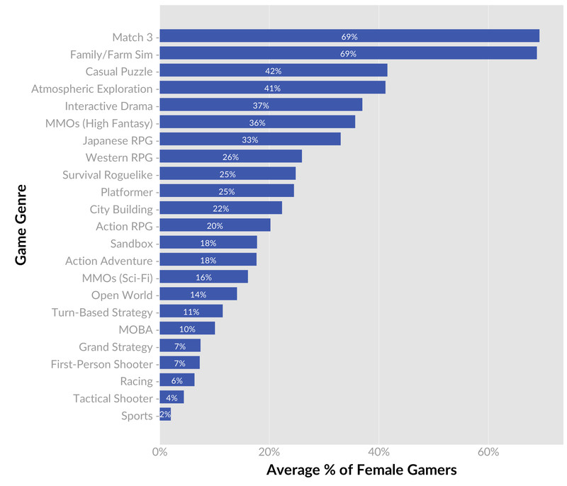

* Based on these stats, I spent a lot of time playing Match 3 games, mainly from King
  + Candy Crush Saga
  + Farm Heroes
  + Blossom Blast
  + Fishdom
* Also played some popular mobile games
  + Fruit Ninja
  + Angry Birds
  + Plants vs Zombies

From this research I noted that;

* + Play button is generally large and distinctive
  + Other buttons are much smaller
    - High scores and options are most common
  + Menu and UI are simple and clean, provide some sort of feedback to the player
  + It’s important to use visual hierarchy
  + Consistencyis key
* **Concepts/mockups for UI uploaded separately**